Stapes Pistons and Ossicular chain prostheses and MRI Safety
www.mrisafety.com

Commonly used Stapes Prostheses/Pistons
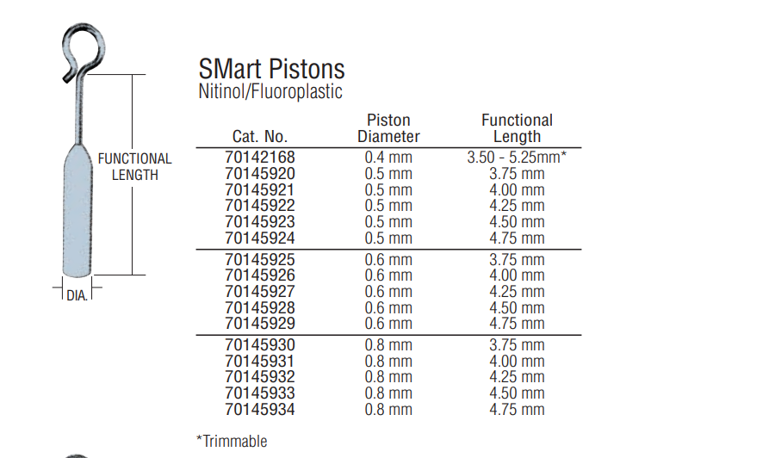
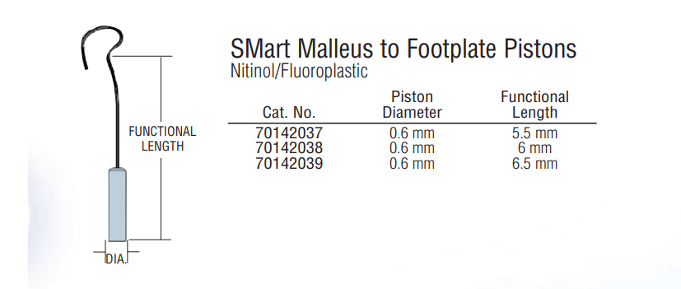
Nitinol and fluoroplastic
Safe to 3T MRI

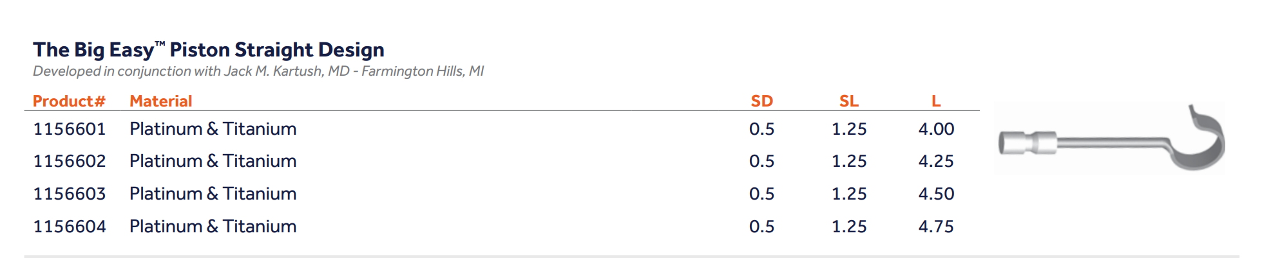
Safe for MRI to 1.5T
Platinum

Commonly Used Ossicular Chain Prostheses
Kurz Medical

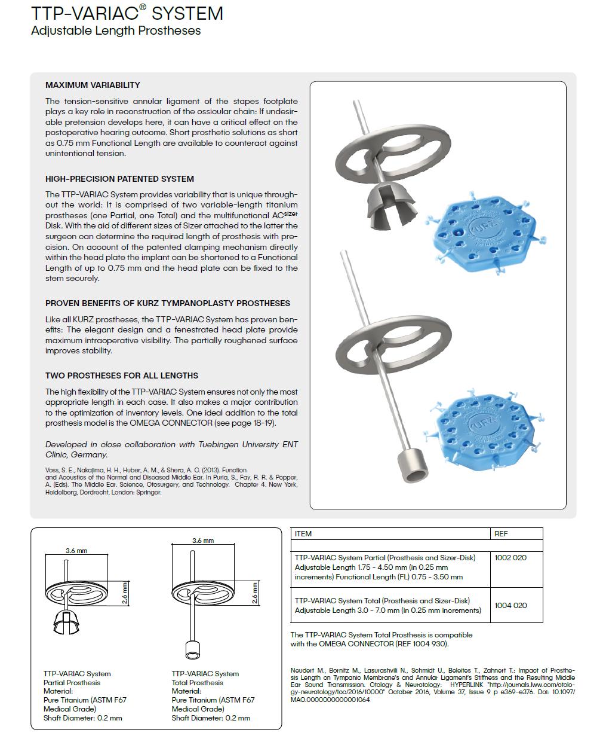
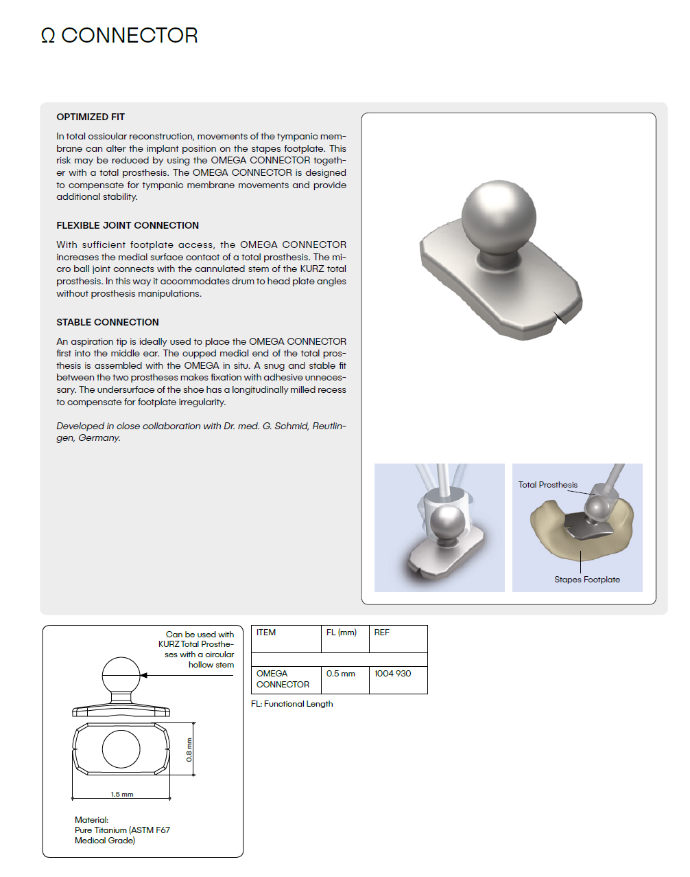
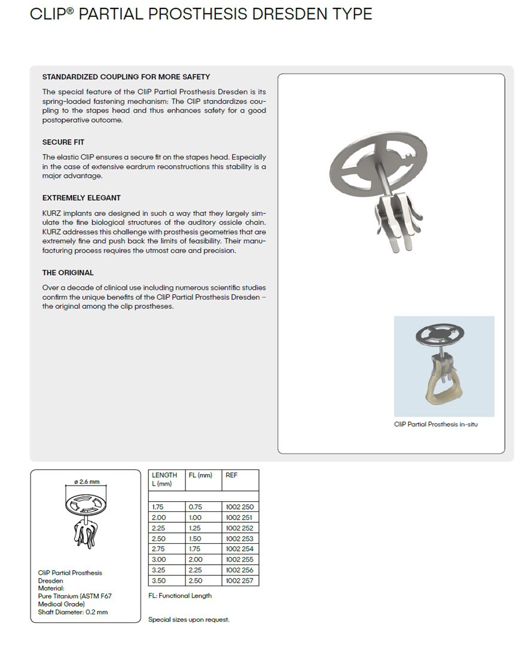
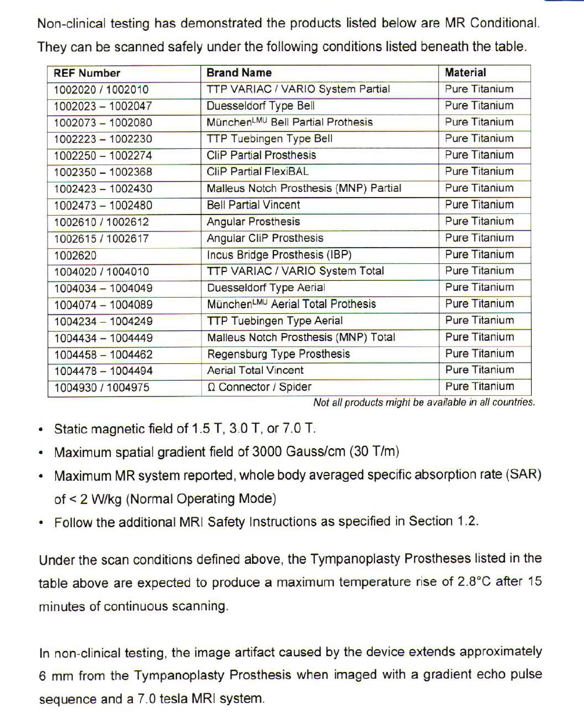

Grace Medical
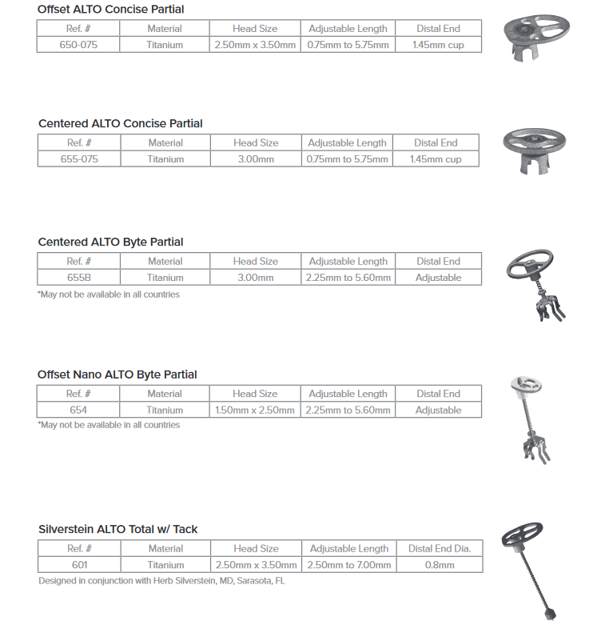
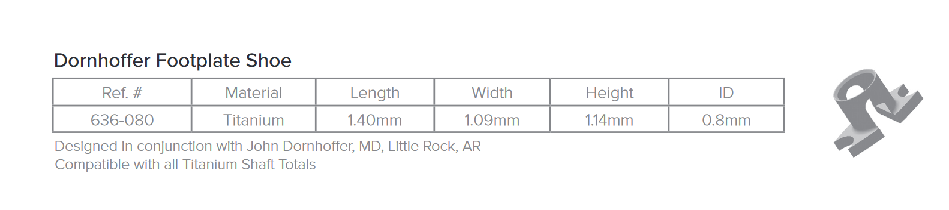
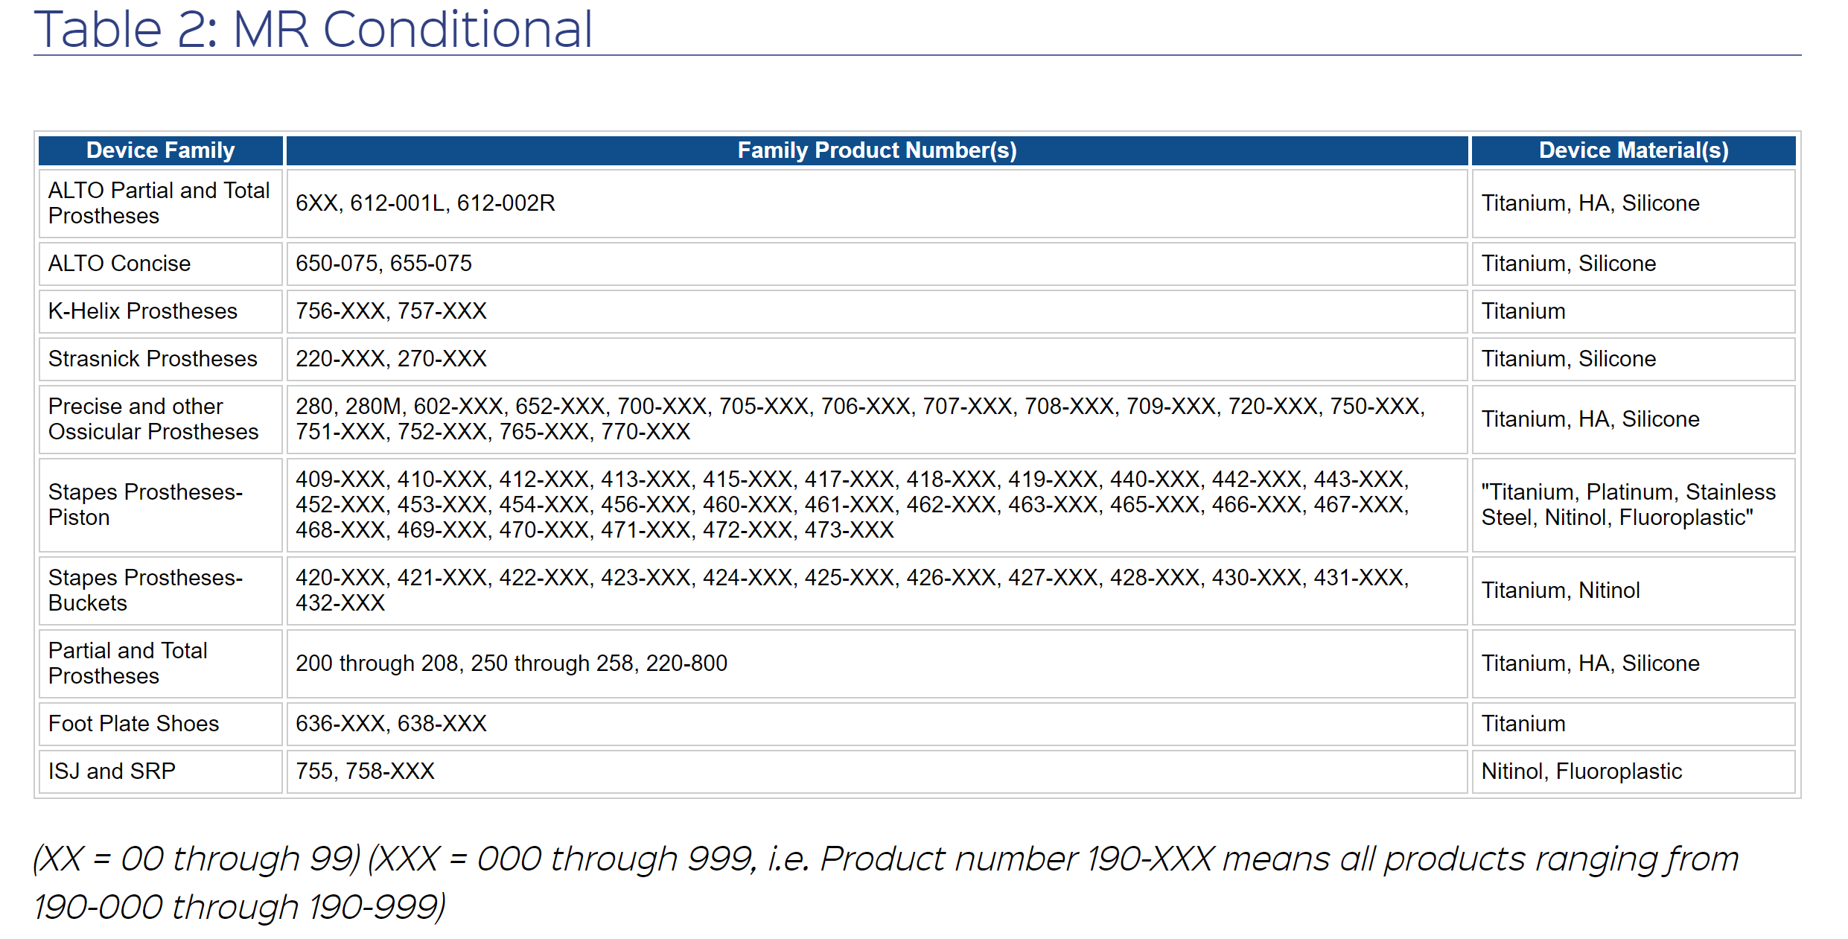

Imaging at 7 Tesla or Less
Non-clinical testing has demonstrated that patients with these specific Grace Medical ossicular implants can undergo MRI safely, immediately after implantation under the following conditions:
- Static magnetic field of 7-Tesla or less
- Maximum spatial gradient magnetic field of 2,000-Gauss/cm or less.
- MR system reported, whole-body-averaged specific absorption rate (SAR) of 4 –W/kg for 15 minutes of scanning (i.e., per pulse sequence).

